When you have symptoms of Covid-19 or you are aware you closely contact to those positive
Please take the Rapid Antigen Test
(You can purchase self-test kit from the close drug store or
convenient stores in & out of the campus )

If Antigen Test Positive
go to the public health center for PCR test carrying the test kit “positive”
(please refer to the public health care center at the below page 6)

If the PCR positive
Contact the close clinic where Non-face to face clinic is possible &
Find quarantine place for 7 days
(please refer to the Quarantine facilities at the below page 4 / Clinic is not mandatory but it is encouraged)

You will have the result of the PCR test text message from the public health center one day after the PCR test
(You need to conduct the self-quarantine
while waiting for the result)

Home treatment for PCR positive
get the Non-face to face clinic with the hospital and get the prescribed drugs
(You can buy over-the-counter medicine drugs such as Tylenol at the drugstore)
(Clinical service and prescribed drugs are on the person’s (tested positive) expenses (please refer to the Home treatment at the below page 5)
Clinic is not mandatory but it is strongly encouraged for your health

Quarantine release
You will get the message saying the release day. At the present 8th day from the you get the PCR test is the release day

<Guidelines for those who test positive for COVID 19 and reside in the dormitory>
* PCR test positive and Basic epidemiological survey
If positive at the PCR test, you will get the text message as the very first square of the below table. You need to complete the basic epidemiological survey which will be given to you through the message from the health center. However, as it is only operated in Korean, the staff from the health center will call you on the phone in English. If you complete the survey on the phone call, you don’t need to fill out the form below.
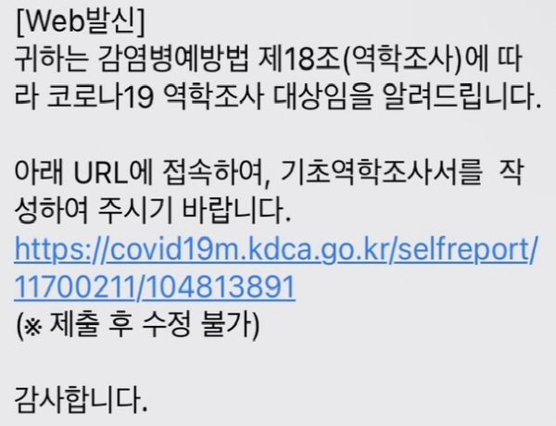 | 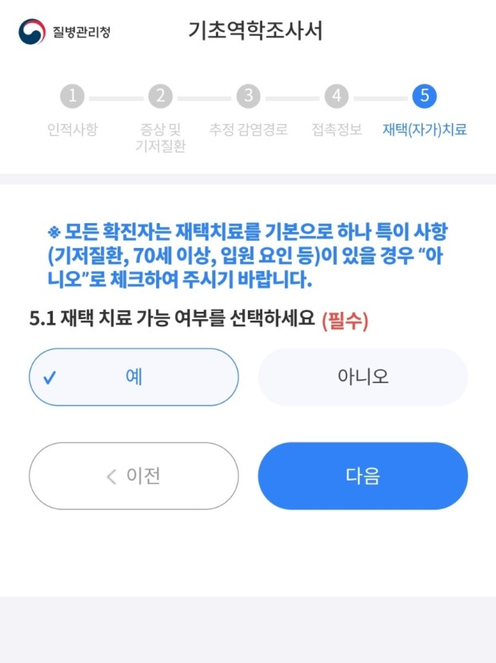
Message which contains the survey link | The basic epidemiological survey.  * It will be operated in Korean, so the staff will call you on the phone in English.  * At No. 5, there is a question of home care. You need to click “Yes” if you stay at Airbnb.

* Quarantine facilities
For everyone’s safety, you have to leave the dormitory and move to one-person quarantine facility. You can book the facility at Airbnb. You can refer to the link below to make a reservation, and otherwise you can find it on your own. Please book the facility near Ajou University, so that you can easily move back and forth. You need to make a reservation to stay for 8 days, because you can be released on 8th day after 7 days of self-isolation. (The quarantine fee is on the person’s own expenses)

Airbnb Link:

https://www.airbnb.co.kr/rooms/53942215?check_in=2022-03-07&check_out=2022-03-14&guests=1&adults=1&s=67&unique_share_id=e6e5a698-347c-4932-9144-855e2751d58f

https://www.airbnb.co.kr/rooms/49575154?check_in=2022-03-07&check_out=2022-03-14&guests=1&adults=1&s=67&unique_share_id=96abf71c-9592-4372-9fba-5b56bba682a3&source_impression_id=p3_1658480427_egbweFD9QYpycaS5

https://airbnb.com/h/jw53?_ga=2.183086758.1869740633.1658480412-140954384.1658480412

https://airbnb.com/h/jh33?_ga=2.183086758.1869740633.1658480412-140954384.1658480412

https://airbnb.com/h/jh43?_ga=2.183086758.1869740633.1658480412-140954384.1658480412

https://www.airbnb.co.kr/rooms/556937555272226514?source_impression_id=p3_16584806 31_GtOrkWS5ada5nbYc

* Transportation from dorm to the facility
Below is the quarantine taxi number. You can contact one of them. However, they will not be good at English, so please request a help to your AGA buddy. The taxi fee will be around 15,000won for half an hour and around 40,000won for an hour. In case it is fully booked, you can take a regular taxi on the app “Kakao taxi.”

* Home treatment
The medical treatment can be conducted by the doctor of Yeonsei Nanum Clinic (연세나눔의원 which is located in front of Ajou University hospital) The treatment will be conducted by phone without meeting in person. You can make an appointment first by contacting them on the phone and providing them with your personal information. Then, they will call you back. The clinic fee will be requested from the hospital per one call : 20,000won ~ 30,000won (It can be variable according to your symptoms) You can send the fee to the hospital’s account. They will let you know the fee and the account number individually after you get a treatment.
Yeonsei Nanum Clinic : 031-212-3133

After the medicine is prescribed, you can ask your AGA buddy to take your prescription from the hospital and submit it to the pharmacy named Health Dream Pharmacy, 건강드림약국. Once they take the medicine from the pharmacy, they will deliver it to your quarantine facility. The fee of prescribed medicine will be varied from 10,000won to 20,000 won (It can be variable according to your symptoms) You can send the fee to the pharmacy’s account. Your AGA buddy will let you know the fee and their account number individually once they take the medicine.
Health Dream Pharmacy : 031-215-3321
* The doctoral clinic is not mandatory but we strongly encourage you to get the clinic and get the prescribed medicine. You can buy over-the-counter medicine drugs such as Tylenol at the drugstore if you do not take the clinic.

* After quarantine

From the 8th day after 7 days of home care, you will be released from quarantine and you can return to the dormitory. You will get the text message one or two days before the quarantine release. It includes quarantine periods and end date of the quarantine.

* The place where you can get the PCR test
☞ Public health care center
- Suwon-si Yeongtong-gu Community Health Center (영통구 보건소 in Korean):
weekdays 09:00~12:00, 14:00~17:00
weekends and holidays 09:00~13:00
You can take the PCR test for free.
(For the PCR test, you should carry the Rapid Antigen Test Kit testing POSITIVE, If your Antigen test is negative you cannot take the PCR test. You can buy the Antigen Test Kit at the convenient stores in & out of the campus or pharmacies)

Location of Public Health care center : 경기 수원시 영통구 영통로 396 (우)16703 :
(Address : Gyunggi-do Suwon-si Yeongtong-gu, Yeongtong-ro 396) / It takes 20-25minutes from Ajou to the Yeongtong-gu Community Health Center (The taxi fee : less than 7,000 ~ 8,000 won)

